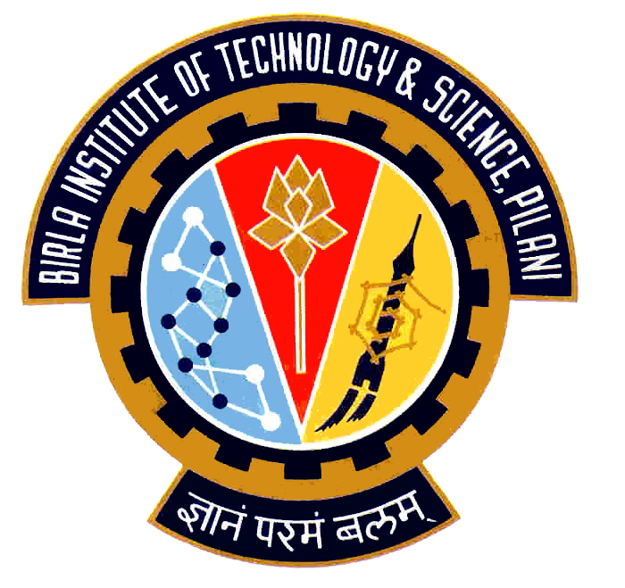

Election Commission

Birla Institute of Technology & Science – Pilani, Goa Campus, Zuarinagar, Goa-403726, INDIA
Tel: (0)98233 6368 Fax:0832-2557033

Final List of Candidates for Hostel Representatives:

AH 4
CULTURAL
ANURAG GAUR | 2005S1P4116
HOSTEL AND CAMPUS MANAGEMENT
KOLETI SANDEEP GUPTA | 2005S1P4804
PRASHANT JULURI | 2005S2P3638
MESS
V. HARI KIRAN | 2005S2P8562
SPORTS
SAGAR LALWANI | 2005S2P7587
PRASANTH K. | 2005S2P1496

The above change has been made by the Election Commission in consultation with the candidate and the Chief Warden.

Chief Warden CEC

CEC Chief Warden

